ITEC301 DELIVERABLE 2
DOCUMENTATION AND CODING

Student Name: | Trent Stanley
Student Number: | LMQF353S5
Project Title: | The Trieune Caterers
Submission Date: | 25 June 2021

Table of Contents
2.1 Table of Contents 2
2.2 Introduction 3
2.3 Prototyping 3
2.4 Designing 5
2.5 Coding 10
2.6 Conclusion 34
2.7 Sign-off 35

Introduction
Provide an introduction in less than 200 words.
The Trieune Caterers has asked for a website that can book events automatically. This document details the planning and code samples of the built website. You will see the logical structure in the form of diagrams using UML standards. You will see the prototypes of the system proposed. You will also see code samples of each aspect of the site

Prototyping
Provide the screen shots of the two responsive prototypes asked in the project specification document. Each prototype must illustrate how all the pages of the website will be displayed on smart phones, tablets and desktops.
- Prototype 1.
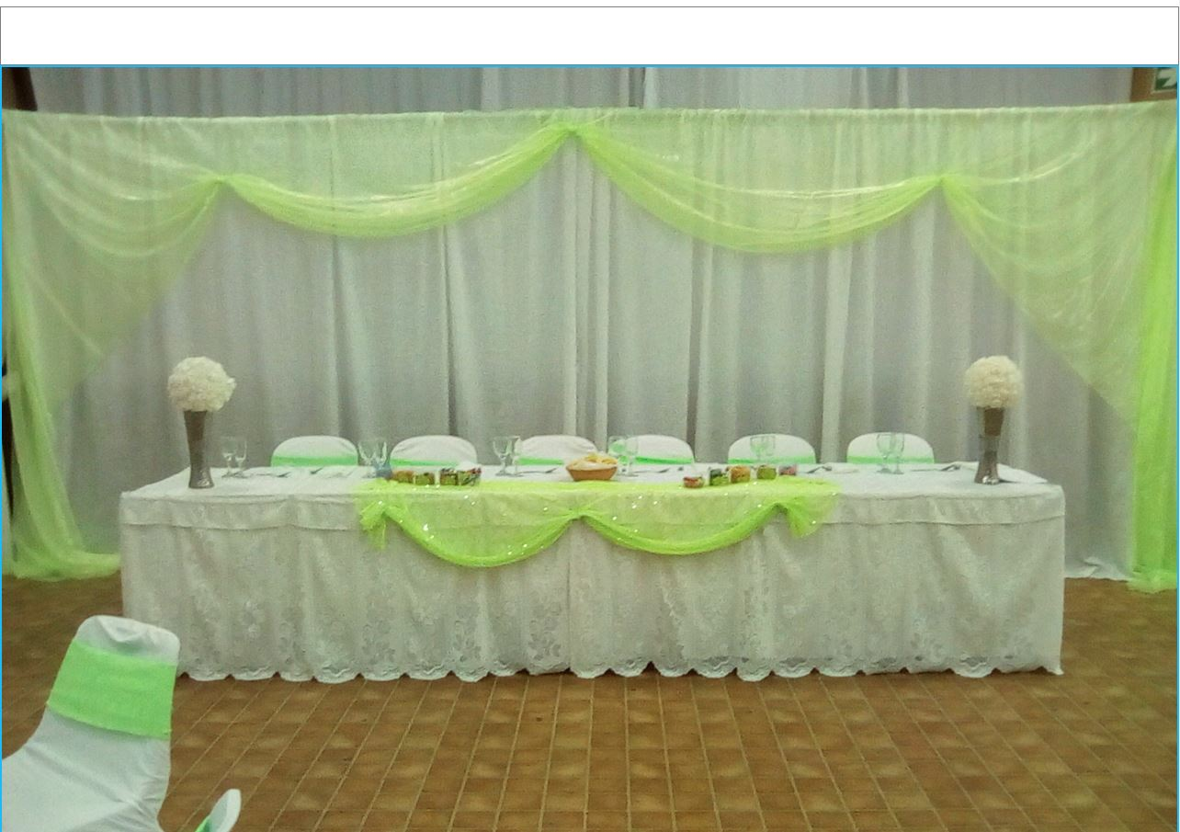
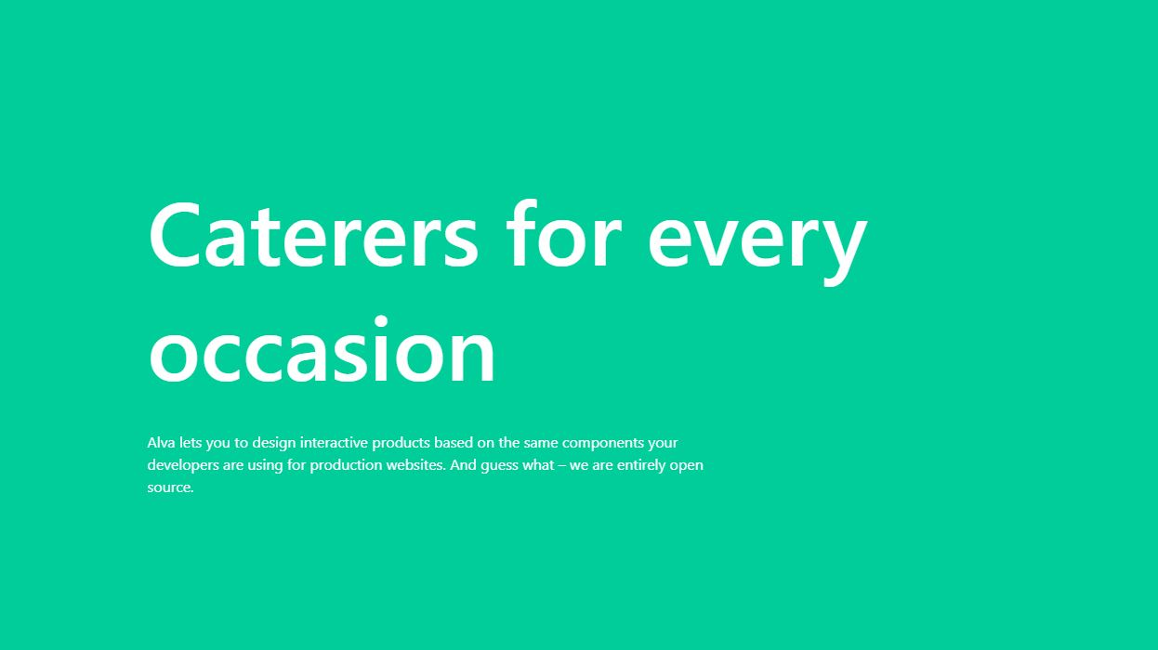
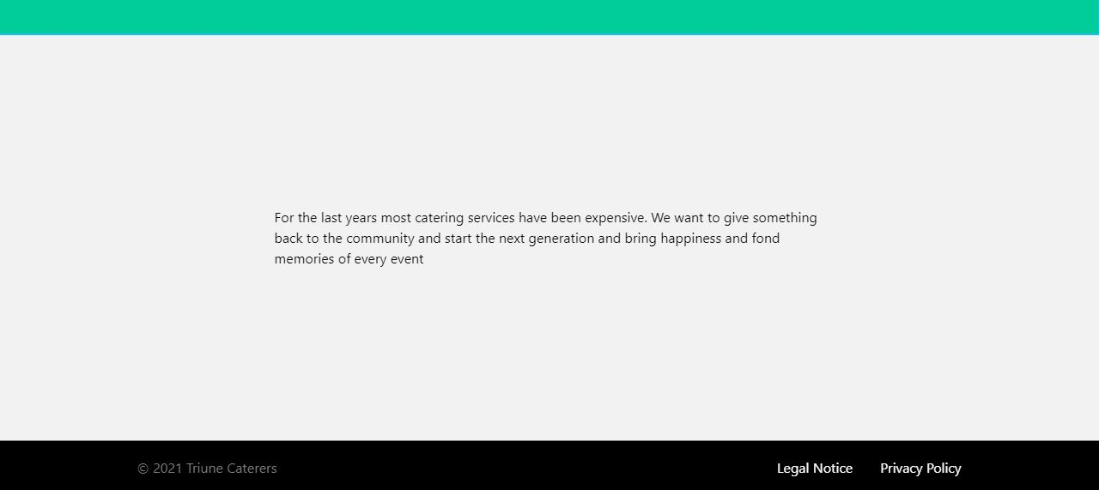
- Prototype 2.
Your customer must select the prototype you should use for the website development.

Designing
- Class Responsibility Collaborator (CRC) cards
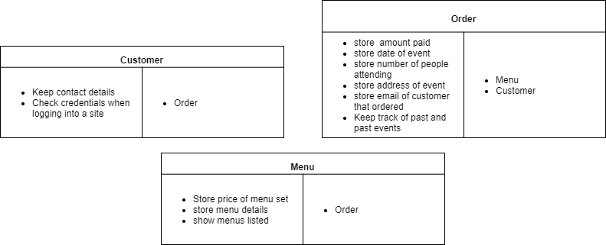

Enhanced Entity Relationship Diagram (EERD)
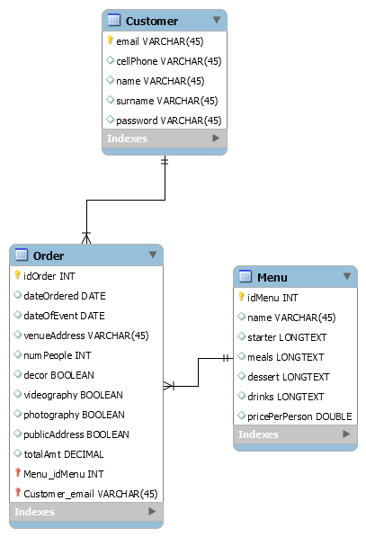

- Context Diagram
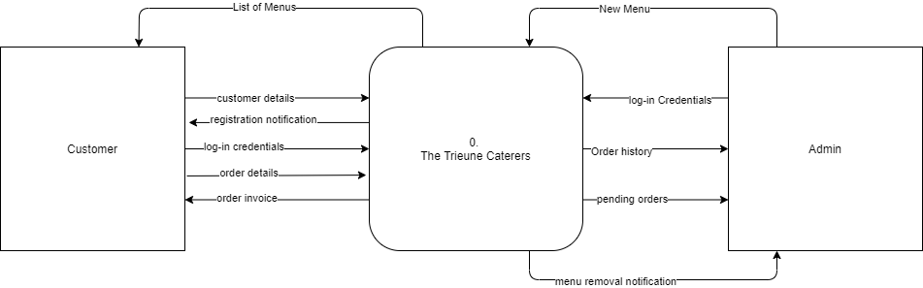
- Data Flow Diagram (DFD)
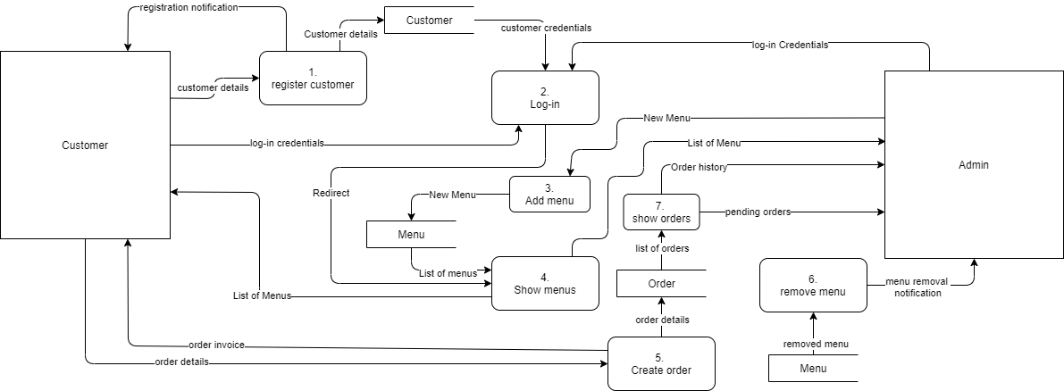

- Use Case Diagram
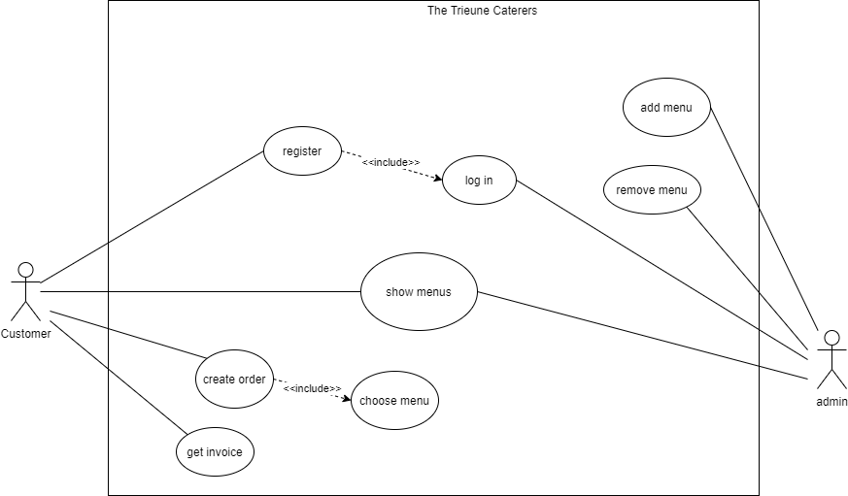

- Database Design
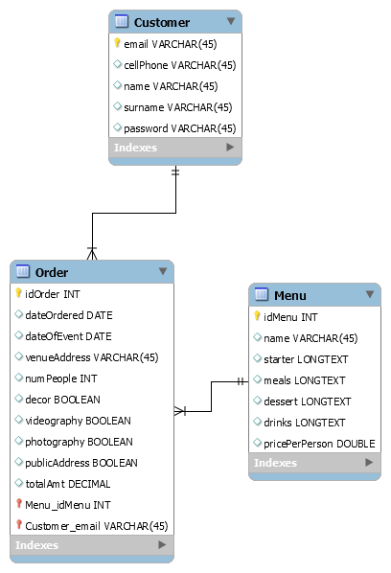

Coding
- Screen shots
Customer
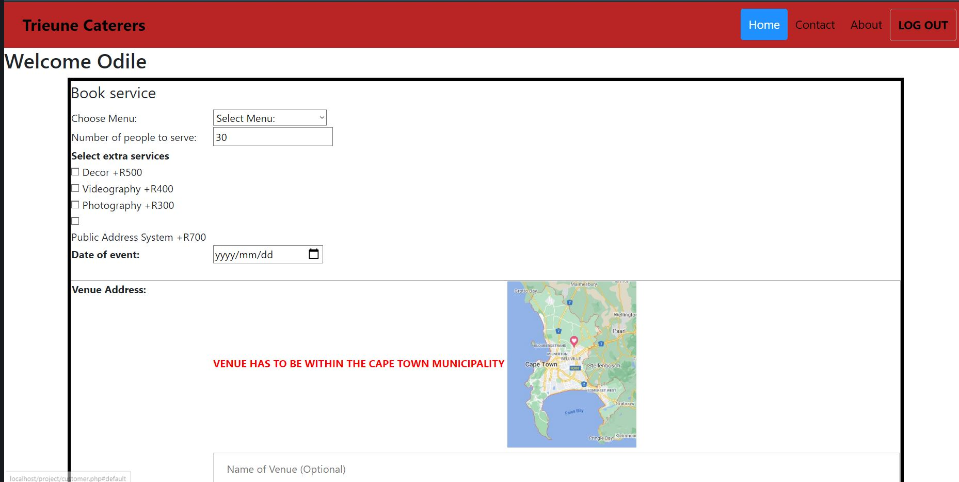
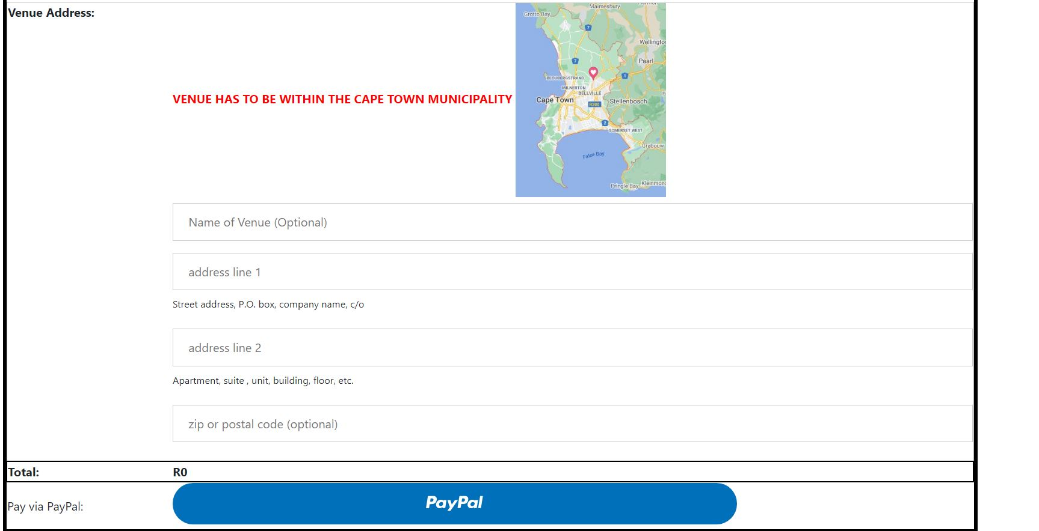
Start menu
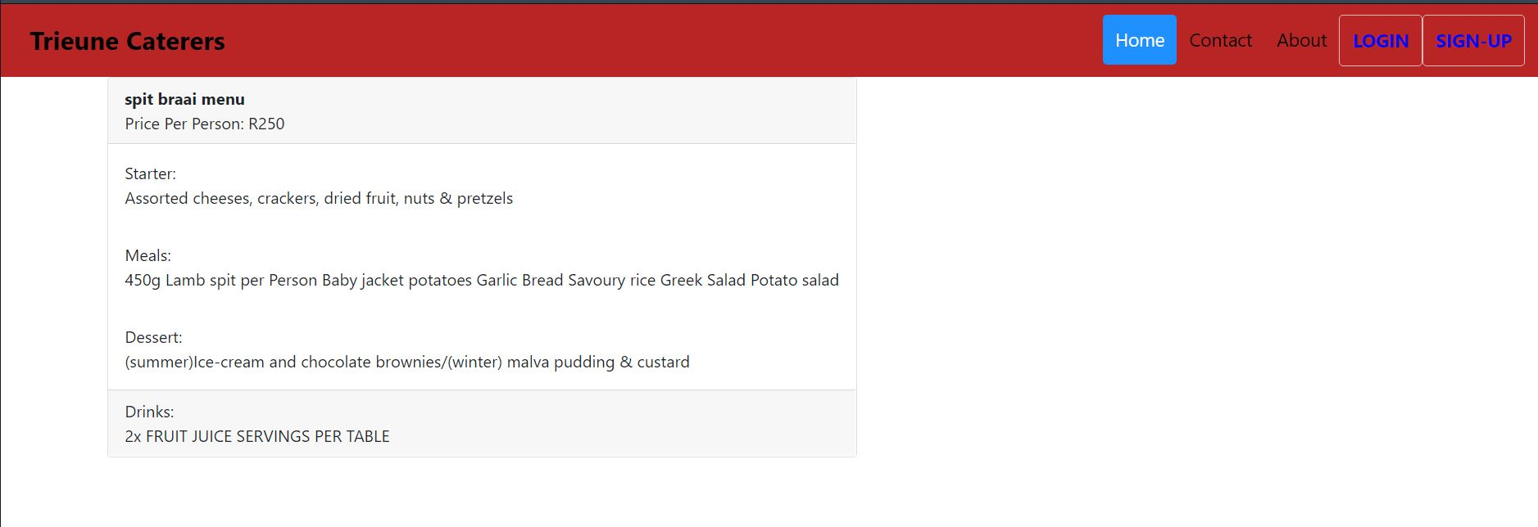

Admin
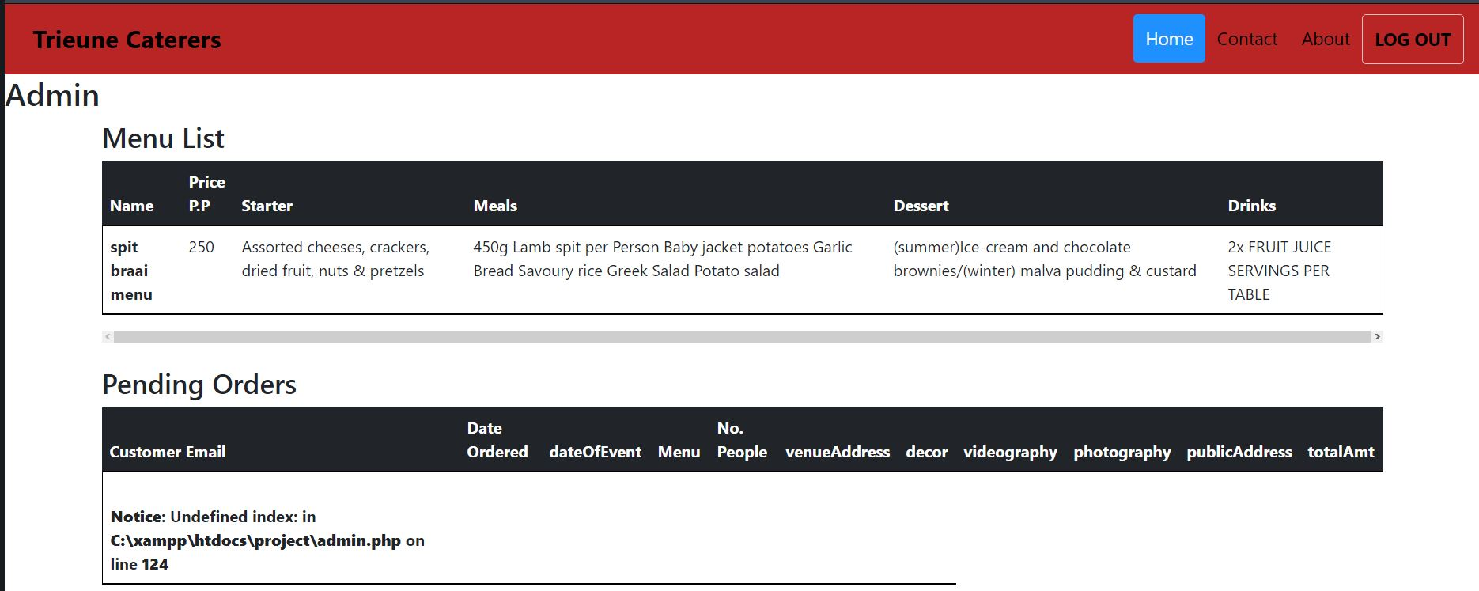
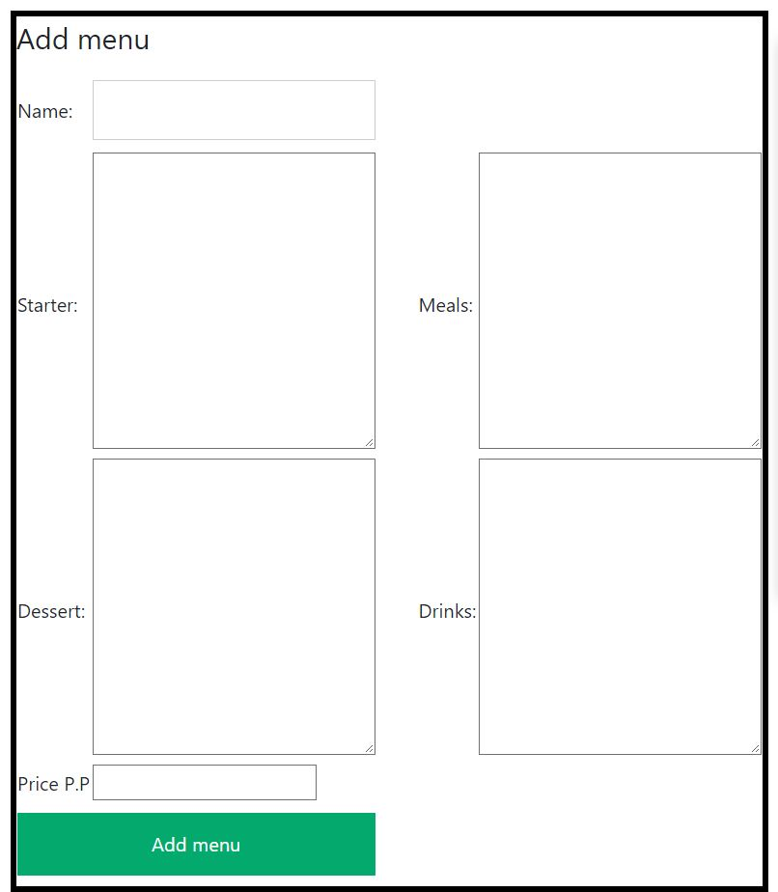

- Sample PHP Code
Main.php
<?php
session_start();
$admin = file_get_contents("admin.json");
$admin = json_decode($admin);

if(isset($_SESSION) && $_SESSION['email'] == $admin->email){
/* $myfile = fopen("admin.php", "r+") or die("Unable to open file!");
echo fread($myfile,filesize("admin.php"));
fclose($myfile); */
header('Location: admin.php');
}else if(isset($_SESSION) && !$_SESSION['email']== null){
header('Location: customer.php');
}else {
//$myfile = fopen("start.php", "r") or die("Unable to open file!");
//echo fread($myfile,filesize("start.php"));
//fclose($myfile);
header('Location: start.php');
}

?>

Logout.php
<?php
session_start();
$_SESSION['email'] = null;
session_destroy($_SESSION);
unset($_SESSION);
header("location: main.php");

?>

Login.php
<?php

include 'database.php';

$email = $_POST['email'];
$password = $_POST['psw'];

$admin = file_get_contents("admin.json");
$admin = json_decode($admin);

$sql = "SELECT `email` , `password` FROM `customer` WHERE `email`='$email'";
$result = $conn->query($sql);

if ($admin->email == $email && $admin->password == md5($password)) {
session_start();
$_SESSION['email'] = $admin->email;
header("Location: admin.php");
exit();
}

while ($row = $result->fetch_assoc()) {
if ($email == $row['email'] && $password == $row['password']) {
session_start();
$_SESSION['email'] = $row['email'];
header('Location: customer.php');
exit();
}
}

header("Location: start.php?error=1");

?>

Register.php
<?php
$email = $_POST['email'];
$name = $_POST['name'];
$surname = $_POST['surname'];
$passw = $_POST['psw'];
$cellNum = $_POST['cellNum'];

session_start();

include 'database.php';
include 'email.php';

$check = $conn->query("SELECT `email` FROM `customer` WHERE email = '$email'");

while($row = $check->fetch_assoc()){
if ($email == $row['email']) {
header("Location: start.php?error=2");
}
}

$sql = "INSERT INTO `customer`(`email`, `cellPhone`, `name`, `surname`, `password`) VALUES ('$email','$cellNum','$name','$surname','$passw')";
$result = $conn ->query($sql);

if($result){
sendmail($email, 'Thank you for registering '. $name);
$_SESSION['email'] = $email;
header('Location: customer.php');
}else if(!$result){
echo 'Registration failed';
$a = 5;
while ($a >= 0) {
echo $a;
sleep(1);
$a--;
}
header('start.php');
}

?>

- Sample HTML Code
Customer.html
<!doctype html>
<html lang="en">

<head>
<!-- Required meta tags -->
<meta charset="utf-8">
<meta name="viewport" content="width=device-width, initial-scale=1">

<!-- Bootstrap CSS -->
<link href="https://cdn.jsdelivr.net/npm/bootstrap@5.0.0/dist/css/bootstrap.min.css" rel="stylesheet" integrity="sha384-wEmeIV1mKuiNpC+IOBjI7aAzPcEZeedi5yW5f2yOq55WWLwNGmvvx4Um1vskeMj0" crossorigin="anonymous">
<link rel="stylesheet" href="css/custom.css">
<title>Customer</title>

</head>
<header>

<div class="header">
<a href="#default" class="logo">Trieune Caterers</a>
<div class="header-right">
<a class="active" href="#home">Home</a>
<a href="#contact">Contact</a>
<a href="#about">About</a>
<a id="logout" href="logout.php">LOG OUT</a>

</div>
</div>

</header>

<body>

<!-- Option 1: Bootstrap Bundle with Popper -->
<script src="https://cdn.jsdelivr.net/npm/bootstrap@5.0.0/dist/js/bootstrap.bundle.min.js" integrity="sha384-p34f1UUtsS3wqzfto5wAAmdvj+osOnFyQFpp4Ua3gs/ZVWx6oOypYoCJhGGScy+8" crossorigin="anonymous"></script>

<!-- Option 2: Separate Popper and Bootstrap JS -->
<!--
<script src="https://cdn.jsdelivr.net/npm/@popperjs/core@2.9.2/dist/umd/popper.min.js" integrity="sha384-IQsoLXl5PILFhosVNubq5LC7Qb9DXgDA9i+tQ8Zj3iwWAwPtgFTxbJ8NT4GN1R8p" crossorigin="anonymous"></script>
<script src="https://cdn.jsdelivr.net/npm/bootstrap@5.0.0/dist/js/bootstrap.min.js" integrity="sha384-lpyLfhYuitXl2zRZ5Bn2fqnhNAKOAaM/0Kr9laMspuaMiZfGmfwRNFh8HlMy49eQ" crossorigin="anonymous"></script>
-->
<? if (isset($_GET)) {
if (isset($_GET['success'])) {
?>
<label><strong><? echo 'order booked' ?></strong> </label>
<? } else if ($_GET['error'] == 2) {?>
<label><strong><? echo 'order failed' ?></strong></label>
<? }
} ?>

<h2>Welcome <? echo $account->fetch_assoc()['name'] ?></h2>

<div class="container">
<div class="row">
<div class="col-md-12">
<fieldset id="forms">
<legend>Book service</legend>
<table>
<tr>
<td>Choose Menu:</td>
<td><select name="menu" id="menu" required>
<option value="0" disabled selected>Select Menu:</option>
<? while ($row = $result->fetch_assoc()) { ?>
<option value="<? echo $row['pricePerPerson'] ?>"><? echo $row['name'] ?>: R<? echo $row['pricePerPerson'] ?></option>
<? } ?>
</select>
</td>
</tr>

<tr>
<td>Number of people to serve:</td>
<td><input type="number" id="numServe" defaultValue=30 value="30" min=30 step="1"></td>
</tr>
<tr>
<th>Select extra services</th>
</tr>
<tr>

<td><input type="checkbox" id="decor" name="decor" value="0">
Decor +R<? echo $prices->decor ?></td>
</tr>
<tr>
<td><input type="checkbox" id="video" name="video" value="0">
Videography +R<? echo $prices->video ?></td>
</tr>
<tr>
<td><input type="checkbox" id="photo" name="photo" value="0">
Photography +R<? echo $prices->photo ?></td>
</tr>
<tr>
<td><input type="checkbox" id="pa" name="pa" value="0">
<label for="pa">Public Address System +R<? echo $prices->pa ?></label>
</td>
</tr>
<tr>
<th>Date of event:</th>
<td><input type="date" min="<? echo date_format($date, "Y-m-d"); ?>" id="eventDate" required /></td>
</tr>
<tr>
<td><label for=""></label></td>
</tr>
<tr style="border: 1px solid DarkGrey ;">
<th style="vertical-align: top;">Venue Address:</th>
<td>
<address>
<strong style="color: red;">VENUE HAS TO BE WITHIN THE CAPE TOWN MUNICIPALITY</strong>
<img src="cape town.JPG" alt="" width="200px">
<input type="text" name="placeName" id="placeName" placeholder="Name of Venue (Optional)">

<!-- address-line1 input-->
<input id="address-line1" name="address-line1" type="text" placeholder="address line 1" required>
<p class="help-block" style="font-size: 13px;">Street address, P.O. box, company name, c/o</p>

<!-- address-line2 input-->
<input id="address-line2" name="address-line2" type="text" placeholder="address line 2">
<p class="help-block" style="font-size: 13px;">Apartment, suite , unit, building, floor, etc.</p>

<!-- postal-code input-->
<input id="postal-code" name="postal-code" type="text" placeholder="zip or postal code (optional)">
<p class="help-block"></p>

</address>
</td>
</tr>
<tr style="border: 2px solid black;">
<th>Total: </th>
<td><strong>R<label id="total">0</label></strong> <label id="rate" hidden><? echo $rate; ?></label> </td>
</tr>
<tr>
<td>Pay via PayPal:</td>
<td>
<div id="paypal-payment-button">

</div>
</td>
</tr>
</table>
</fieldset>
</div>
</div>

<div class="row"></div>
</div>

- Sample JavaScript Code
Paypal.js
paypal.Buttons({
style : {
color: 'blue',
shape: 'pill'
},
createOrder: function (data, actions) {
return actions.order.create({
purchase_units : [{
amount: {
value: parseFloat(document.getElementById('total').innerHTML) * parseFloat(document.getElementById('rate').innerHTML)
}
}]
});
},
onApprove: function (data, actions) {
return actions.order.capture().then(function (details) {
console.log(details)

window.location.replace("success.php")
})
},
onCancel: function (data) {

window.location.replace("customer.php?error=2")
}
}).render('#paypal-payment-button');

- Sample CSS Code
/* Style the header */

/* Page content */
.content {
padding: 16px;
}

/* The sticky class is added to the header with JS when it reaches its scroll position */
.sticky {
position: fixed;
top: 0;
width: 100%
}

/* Add some top padding to the page content to prevent sudden quick movement (as the header gets a new position at the top of the page (position:fixed and top:0) */
.sticky + .content {
padding-top: 102px;
}

/* Style the header with a grey background and some padding */
.header {
overflow: hidden;
background-color: #f1f1f1;

padding: 10px 16px;
background: rgb(185, 37, 37);
color: #0c08e0;
}

#forms{
border: 5px solid black;
max-width: fit-content;

}

#loginBtn, #sign-upBtn, #logout {
font-weight: bold;

border: 1px solid rgb(230, 191, 190);

}

/* Style the header links */
.header a {
float: left;
color: black;
text-align: center;
padding: 12px;
text-decoration: none;
font-size: 18px;
line-height: 25px;
border-radius: 4px;
}

/* Style the logo link (notice that we set the same value of line-height and font-size to prevent the header to increase when the font gets bigger */
.header a.logo {
font-size: 25px;
font-weight: bold;
}

/* Change the background color on mouse-over */
.header a:hover {
background-color: #ddd;
color: black;
}

/* Style the active/current link*/
.header a.active {
background-color: dodgerblue;
color: white;
}

/* Float the link section to the right */
.header-right {
float: right;
}

/* Full-width input fields */
input[type=text], input[type=password], input[type=email] {
width: 100%;
padding: 12px 20px;
margin: 8px 0;
display: inline-block;
border: 1px solid #ccc;
box-sizing: border-box;
}
/* The Modal (background) */
.modal {
display: none; /* Hidden by default */
position: fixed; /* Stay in place */
z-index: 1; /* Sit on top */
left: 0;
top: 0;
width: 100%; /* Full width */
height: 100%; /* Full height */
overflow: auto; /* Enable scroll if needed */
background-color: rgb(0,0,0); /* Fallback color */
background-color: rgba(0,0,0,0.4); /* Black w/ opacity */
padding-top: 60px;
}

/* Modal Content/Box */
.modal-content {
background-color: #fefefe;
margin: 5% auto 15% auto; /* 5% from the top, 15% from the bottom and centered */
border: 1px solid #888;
width: 80%; /* Could be more or less, depending on screen size */
}
/* The Close Button (x) */
.close {
position: absolute;
right: 25px;
top: 0;
color: #000;
font-size: 35px;
font-weight: bold;
}
/* Add Zoom Animation */
.animate {
-webkit-animation: animatezoom 0.6s;
animation: animatezoom 0.6s
}

@-webkit-keyframes animatezoom {
from {-webkit-transform: scale(0)}
to {-webkit-transform: scale(1)}
}

@keyframes animatezoom {
from {transform: scale(0)}
to {transform: scale(1)}
}
.close:hover,
.close:focus {
color: red;
cursor: pointer;
}

/* Set a style for all buttons */
button {
background-color: #04AA6D;
color: white;
padding: 14px 20px;
margin: 8px 0;
border: none;
cursor: pointer;
width: 100%;
}

button:hover {
opacity: 0.8;
}

/* Extra styles for the cancel button */
.cancelbtn {
width: auto;
padding: 10px 18px;
background-color: #f44336;
}

.card{
width: fit-content;
}
/* Add media queries for responsiveness - when the screen is 500px wide or less, stack the links on top of each other */
@media screen and (max-width: 500px) {
.header a {
float: none;
display: block;
text-align: left;
}
.header-right {
float: none;
}

span.psw {
display: block;
float: none;
}
.cancelbtn {
width: 100%;
}
}

- Sample MySQL Table Screen shots
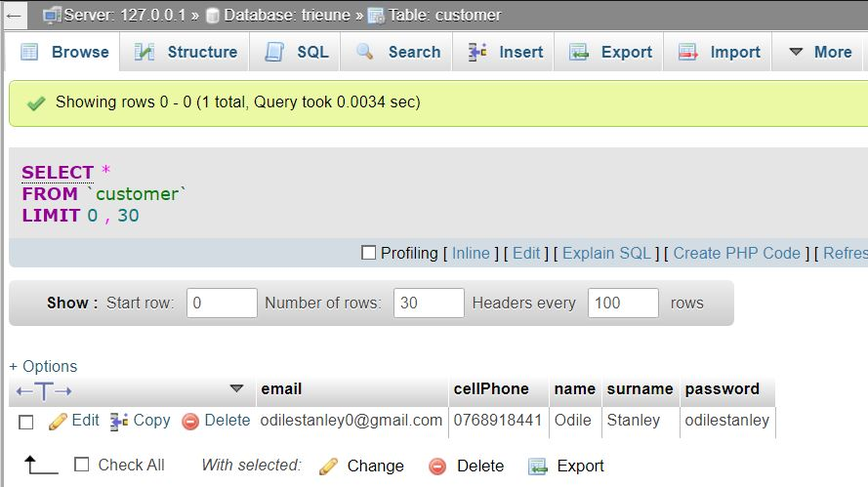
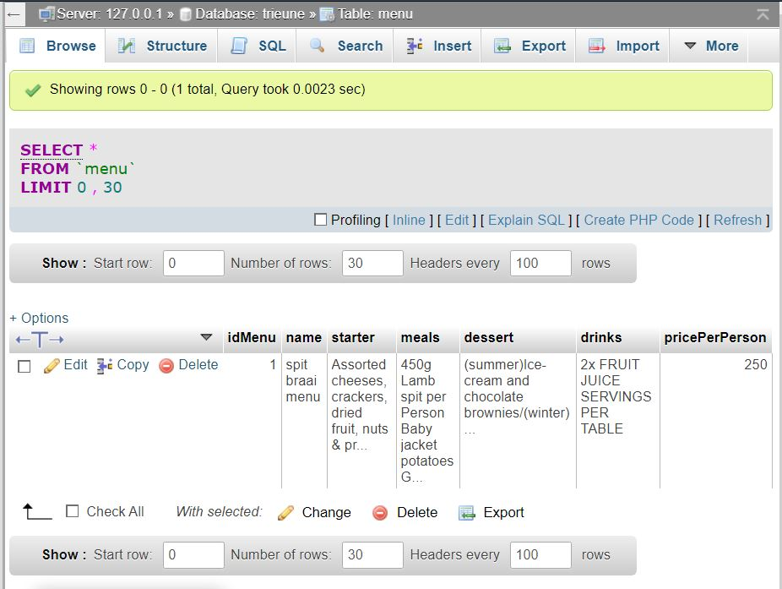
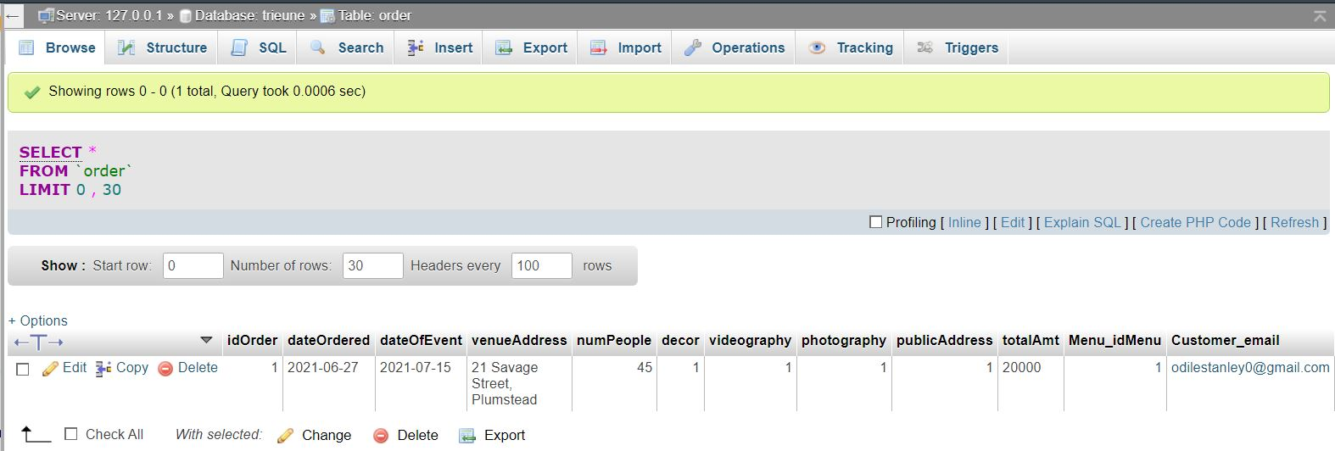

Conclusion
This has been an extreme learning experience as I have learned about the complexities of front-end and back-end coding and the method of implementing a payment system like PayPal.

Sign-off
Justin Charles Palm, Project Client  Date: _____________________ |  |  | Trent Stanley, Project Manager  Date: _____________________

